Davlatoy Beknazarova and her family live in a small village of Khatlon province in Tajikistan.
In 2001, Davlatoy’s husband was sentenced to 13 years in prison. For eight years, Davlatoy lived with her husband’s parents and her two small children, but in 2009, she moved back in with her mother and father, leaving her children with her mother to sell pies. She didn’t make much money, and her brothers’ wives, who also lived in the house, were unkind. Finally Davlatoy started sewing at home, earning money from making clothes, pillows and traditional mattresses for her neighbors, and in 2013, her husband was released from prison.
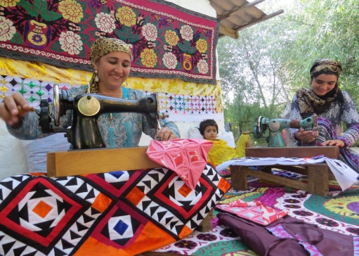
In early 2016, during focus groups on needs assessment, USAID’s Women’s Entrepreneurship for Empowerment Project selected Davlatoy as an eligible beneficiary, and invited for a three-day training course. 15 girls and women from the district attended participated in the training. The project, implemented by the National Association of Business Women of Tajikistan, empowers women who are currently economically inactive to start their own businesses in various entrepreneurship spheres.
Davlatoy participated in the business start-up training and showed a great desire to learn, attending trainings on patchwork, professional development, and participating in business fairs and exhibitions held throughout the country. Davlatoy is known for her wallets and handbags, and her patchwork is of high quality. She sells her products to her neighbors and neighboring villages, and at exhibitions and fairs that happen in neighboring cities.
According to Davlatoy, she earns $100 each month from sewing and is confident that she can earn more income if she works harder.
Women’s Entrepreneurship for Empowerment Project invited Davlatoy to attend their Training for Trainers, where she learned to train other women in the same skills.
In February 2017, Davlatoy held six-day patchwork training for the first time for 15 housewives and dressmakers and received a salary of $240. She expressed her gratitude, saying that this project gave her the opportunity to take the first steps in business.
Today, Davlatoy and her husband consider themselves happy and peaceful. They recently organized a wedding party of their elder daughter, and Davlatoy’s next goal is to open her own sewing shop in her village.
The project runs from October 2014 to September 2017. It empowers women to start their small businesses and increase their income, and also positively influences societal attitudes towards women’s microenterprise, through development of coeducational business education with youth and through government.

