January 2024
THEORY OF CHANGE GUIDANCE FOR RESILIENCE FOOD SECURITY ACTIVITIES V2.0
USAID
BUREAU FOR HUMANITARIAN ASSISTANCE

TABLE OF CONTENTS

1. ACRONYMS AND ABBREVIATIONS 2
2. OVERVIEW 3
3. REQUIREMENTS 3
4. DEVELOPING THE THEORY OF CHANGE 6
5. REVIEWING THEORIES OF CHANGE 13
6. RESOURCES 15

1. ACRONYMS AND ABBREVIATIONS

AOR | Agreement Officer’s Representative
BHA | Bureau for Humanitarian Assistance
IGA | Income-Generating Activity
IPTT | Indicator Performance Tracking Table
LOA | Life of the Award
LogFrame | Logical Framework
M&E | Monitoring and Evaluation
MTE | Midterm Evaluation
PIRS | Performance Indicator Reference Sheet
PREP | Pipeline and Resources Estimate Proposal
QuIPS | Qualitative Inquiry Planning Sheet
RFSA | Resilience Food Security Activity
TOC | Theory of Change
USAID | U.S. Agency for International Development

2. OVERVIEW

The U.S. Agency for International Development’s (USAID) Bureau for Humanitarian Assistance (BHA) funds resilience food security activities (RFSAs) with an objective to improve and sustain the food and nutrition security of vulnerable populations. USAID applies the best available evidence to document activity effectiveness and improve activity design and implementation. BHA has an obligation to the federal government and the American people to ensure that resources are used efficiently to achieve the best possible food security outcomes and that, in the process, food assistance actors learn from experience how to improve activity design and implementation.

This BHA Theory of Change Guidance for Resilience Food Security Activities describes key requirements for BHA RFSA applicants and awardees. This guidance reflects BHA’s approach to RFSA design, including the refinement (or contextualization) periods that enables recipients and USAID to focus on formative research and/or analysis in the first phase of an activity life cycle and then further refine the technical approach(es) that will be carried out in the second phase of the activity life cycle.

The majority of the content and structure of the BHA Theory of Change Guidance for Resilience Food Security Activities originates or is derived from the Technical Guidance for Monitoring, Evaluation, and Reporting for Resilience Food Security Activities V2.0 (May 2021). The BHA Theory of Change Guidance for Resilience Food Security Activities serves as a complementary set of guidance to the Technical Guidance for Monitoring, Evaluation, and Reporting for Resilience Food Security Activities V2.0 (May 2023).

3. REQUIREMENTS

Every BHA RFSA award must include a Theory of Change (TOC) demonstrating the pathway(s) towards achieving the intended goal. The complete TOC describes how all the Outputs from the proposed interventions (and Outputs from interventions from other actors or stakeholders) will contribute to the Outcomes and, ultimately, the activity Goal. The TOC must be developed based on evidence and should include two parts: (1) a diagram or set of diagrams that illustrates the pathways of change that connect the activity results statements, and (2) complementary information presented either in a narrative or table that further explains and adds to the plausibility of the pathways depicted in the diagram(s).

FIGURE 1. DEFINITION OF TOC TERMS
Abridged Theory of Change: A TOC graphic and complementary documentation that includes the incremental, causal linkages from the Goal, Purpose, Sub-purpose, and Intermediate Outcomes that contribute directly to the sub-purposes. Intermediate Outcomes that feed into other Intermediate Outcomes (sometimes called lower-level outcomes) should not be included in the Abridged TOC. It does not include output or intervention-level components.
Assumptions: The contextual or environmental factors or conditions that are out of the control of the activity but have significant influence over the success of the TOC overall or some portion of it. Assumptions can contribute to the TOC in a positive way, or they may represent risks to its success.
Complete Theory of Change: A TOC graphic and complementary documentation that includes the full causal pathway from output to the Goal, including Purposes, Sub-purposes, all levels of Intermediate Outcomes, and Outputs.
Goal: The highest-level outcome to which an activity can contribute. Typically, a goal cannot be fully accomplished during the award period. Factors beyond the control of the activity must also be addressed before the goal can be fully accomplished, or achievement will take longer than the life of the award (LOA). The goal is the ultimate objective of the activity and is directly linked to a BHA Strategic Objective (SO) and/or a USAID country Development Objective. An example of a goal for a BHA activity could be “Sustainable food security in households of XXX province achieved.”
Interventions: Specific actions that take place under an activity and are typically performed by a recipient.
Outcomes: Changes that are expected to happen when all necessary and sufficient preconditions are met. These might include changes in the ecologic, economic, or governance environment; people’s knowledge or attitudes; or cultural beliefs or practices. Outcomes include the Purposes, Sub-Purposes and Intermediate Outcomes within a RFSA LogFrame. Outcomes may also be external to the program.
Outputs: Tangible, immediate product of an intervention under the activity’s control or influence. Examples include “Number of people trained,” “Quantity of food rations distributed,” “Number of groups formed,” and “Number of different types of infrastructure rehabilitated or improved.” Outputs are typically preconditions for Outcomes.
Pathways: The sequence in which Outputs and Outcomes are expected to lead to the Goal. In the TOC diagrams, pathways are depicted using arrows.
Preconditions: The conditions that must exist (e.g., outcomes and outputs, whether activity or externally produced, and assumptions) before a higher-level outcome can be achieved. For example, preconditions might include infrastructure improvements carried out by another actor; shifts in a population’s use of the infrastructure inspired by activity efforts; policy changes; or assumptions that existing political, social, cultural, or natural environment conditions will remain in place throughout the LOA.
Rationales: A statement of logic and/or evidence of the connection in a pathway when the plausibility of the connection may not be obvious to the reader. This includes facts or other information to explain why a precondition is necessary and sufficient to ensure an Outcome. For example, a rationale might refer to literature or other evidence that shows infants in high mental stimulation environments have better growth outcomes compared to those who are in low-stimulation environments. Full explanations of rationales should be included in the TOC complementary documents.
Results Statements: Parts of the TOC that are within the manageable interest of the recipient (and will be carried over into the LogFrame).
TOC Diagrams: A set of diagrams that use shapes, text, color, and arrows to show the hypothesized pathways of change from Outputs to Goal, plus the critical rationales and assumptions underlying the TOC.

TOC REQUIREMENTS DURING THE APPLICATION PROCESS
BHA requires applicants to provide an abridged TOC diagram and complementary documentation as part of every application. The abridged TOC should display the incremental, causal linkages from the Goal, Purpose, Sub-purpose, and Intermediate Outcomes that contribute directly to the sub-purposes. The TOC should reflect all relevant higher-level outcomes in the TOC regardless of which entities (i.e., the BHA recipient, another NGO, or local government) are implementing them. The TOC should also include assumptions and/or hypotheses about the operational, geographic, and cultural context. The complementary documentation narrative or table outlines the evidence base, clarifies rationales, assumptions, and associated risks. See figure 3 for an example of an abridged TOC diagram compared to a complete TOC diagram.

TOC REQUIREMENTS AT THE REFINEMENT OR CONTEXTUALIZATION PERIOD
During the refinement period, awardees will use additional evidence and improved knowledge to refine and develop a complete TOC and the complementary documentation. The complete TOC will include a full TOC Diagram, including the full causal pathway(s) from output to Goal, and TOC narrative or table.

TOC REQUIREMENTS DURING THE IMPLEMENTATION PERIOD
The TOC should be modified throughout the activity and revised TOCs must be submitted with the annual M&E Plan submission, three months prior to PREP submission. At a minimum, the TOC should be reviewed by program staff at minimum annually, and whenever there is new evidence or when there are changes in the context that affect assumptions or hypothesized pathway(s) of change. When submitting a revised TOC, the recipient should describe and justify all modifications and explain how changes to the TOC will affect activity design and implementation. All changes to the TOC must also be reflected in the other required M&E documents (particularly the LogFrame, IPTT, PIRS, and QuIPS), as described in the Technical Guidance for Monitoring, Evaluation, and Reporting for Resilience Food Security Activities V2.0 (May 2023).

FIGURE 2. SUMMARY OF TOC REQUIREMENTS THROUGHOUT THE LOA
Application | Start-Up and Refinement or Contextualization Period | Annually | Midterm
Develop an abridged TOC, including diagrams that identify the Goal, Purpose, Sub-purpose, and Intermediate Outcomes that contribute directly to the sub-purposes, as well as the complementary documentation in narrative or table outlines evidence base, clarifies rationales, assumptions, and associated risks. | Refine with additional evidence and improved knowledge through the refinement or contextualization period. This includes a complete TOC Diagram, including the full causal pathway(s) from output to Goal, and TOC complementary narrative or table. | Revise and resubmit annually, three months prior to PREP submission. | TOC should be updated based on findings from the Midterm Evaluation (MTE)/ Process Evaluation.

The complete TOC diagrams should show not only how Outcomes will be achieved but also how key Outcomes will be sustained over time. The complete diagram and complementary documentation should be developed during the refinement or contextualization phase, which would include the outputs that contribute towards an outcome. For example, TOC diagrams that include provision of extension services to farmers by activity staff should demonstrate how other service providers will support farmers to continue implementing key agricultural practices beyond the life of the activity. BHA strongly recommends prioritizing outcomes that will make transformative, sustainable changes to the target population. To prioritize outcomes, applicants need to consider the outcomes that are drivers of the purpose level outcome and the outcomes that will be sustainable. If an outcome is not critical to contribute to a transformative change at the purpose level, and the outcome will not be included in the sustainability plan, the outcome should not be included in the activity design.

The TOC must also show contextual factors that are not addressed directly by the activity’s interventions but that are necessary for hypothesized changes to occur. This includes critical anticipated Outputs and Outcomes from concurrent interventions (e.g., other donor-funded activities or host government programs), as well as assumptions (contextual conditions that influence the desired changes in the TOC but are outside of the control of the program). These should be included as preconditions in the TOC diagram and described in the narrative, further guidance is below.

FIGURE 3. EXAMPLE ABRIDGED AND COMPLETE THEORY OF CHANGE GRAPHICS
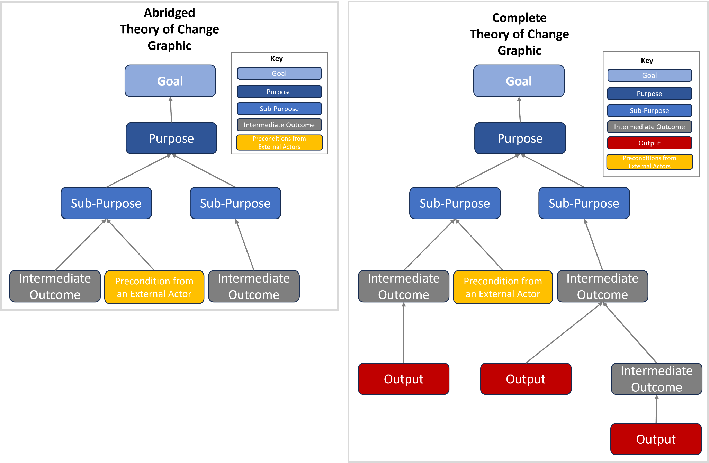

4. DEVELOPING THE THEORY OF CHANGE

The process of defining a TOC should start from the activity Goal and work down through the various pathways. Immediate preconditions for the highest-level Purposes and Outcomes in a TOC are typically not direct Outputs of activity interventions or existing conditions. Therefore, other preconditions are necessary before the immediate preconditions can be achieved. These lower-level preconditions must be portrayed in the TOC. The process of identifying preconditions should continue, step by step, until reaching an activity Output or an externally produced outcome or output.

To illustrate, a portion of a TOC is portrayed in Figure 4. This illustration shows how “Household access to nutritious food improved” is an activity Purpose, and a Sub-Purpose is “Household income increased.” In this example, one way the activity expects to increase household income is by promoting household members’ participation in new income-generating activities (IGAs). To promote participation, activity staff will train women in IGA skills, and other interventions will address aspects of the economic environment that limit the participation of individuals in IGA skills.

Figure 4 shows that “Household income increased” is a precondition for the Purpose. “Household members participate in new IGAs” is a precondition for “Household income increased.” Participation, in turn, is an Outcome of the two preconditions: “Women trained in IGA skills” and “Economic environment for IGAs improved.” Women’s training is a direct Output of the activity’s interventions, and there is no precondition leading to that box. Outputs typically begin pathways. However, on rare occasions, outputs may have other preconditions, such as an outcome or output external to the program.

FIGURE 4. EXAMPLE OF PRECONDITIONS IN A TOC
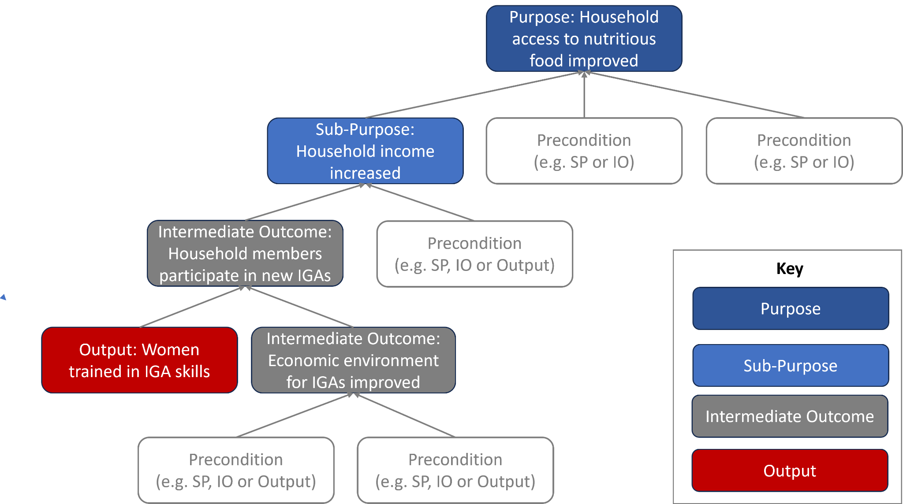
In TOC diagrams, BHA recommends the use of colors, numbers, fonts, shading, and/or shapes to distinguish the different elements of the TOC and the LogFrame and to distinguish Outcomes from preconditions outside the activity’s control from those influenced by the activity (see Figure 5 as an example). Every TOC diagram should include a key that explains the significance of the colors, fonts, shading, etc.

Assumptions and rationales should be inserted in TOC diagrams using a unique font, shape, or color. An assumption or rationale underlying or justifying a pathway between a precondition and Outcome should be shown in a shape that points toward the arrow that connects that precondition and Outcome. If the text needed to describe an assumption or rationale makes a diagram too crowded, a simple identifier (for example, A1, R2, etc.) that refers to a description of the assumption or rationale in the TOC narrative or an attached table may be positioned on the diagram to show its relationship to the related Outcome, Output, or pathway (see Figure 5).

All outcomes and outputs in the TOC, whether produced by the activity or an external actor, should be stated as results, not processes. For example, the results of training could be “Caretakers of children aged 6–36 months trained to prepare foods to complement breastfeeding,” not “The activity trains caretakers of children aged 6–36 months to prepare foods to complement breastfeeding.”

FIGURE 5. EXAMPLE SHOWING COLOR AND SHAPE TO DISTINGUISH TOC ELEMENTS
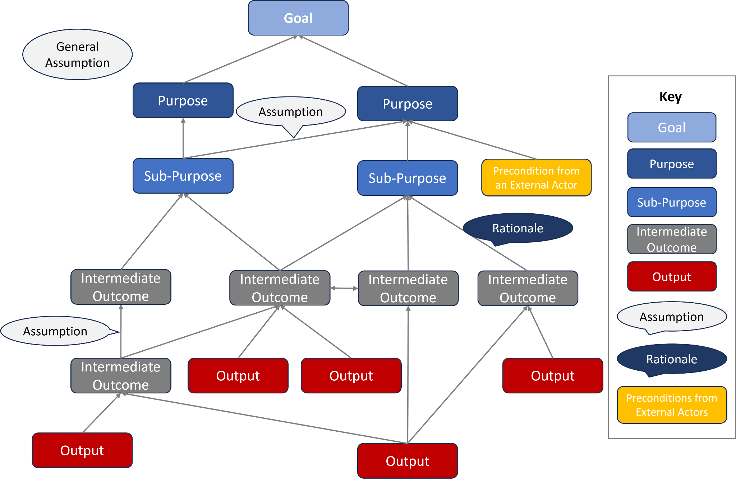

Because BHA resilience activities are multi-sectoral and complex, an activity TOC diagram may not fit onto a single page. To keep the diagrams reader-friendly while maintaining detail, the TOC should comprise either a diagram or a set of diagrams (e.g., one summary diagram with each purpose and additional purpose specific diagrams). Some pathways in the TOC may overlap across Purposes or Sub-Purposes. Figure 6 shows one way that a crossing might be depicted by repeating the Outcome that appears on the page with the pathways leading up to it on a second page where the Outcome is a precondition for a higher-level Outcome. Likewise, the higher-level Outcome on the second page could be repeated on the first page. Color, shape, or formatting should be used to identify a precondition or Outcome that also appears on another page. (Note that the yellow-lined ovals and arrows are not part of the TOC diagram. They are added in this figure only to direct the reader to the repeated elements.)

BHA requests that, in addition to the set of Purpose- or Sub-Purpose-level diagrams, the recipient include a single-page, all-inclusive diagram. BHA does not require any specific software for developing and presenting TOC diagrams.

FIGURE 6. SHOWING PATHWAYS THAT CROSS DIAGRAMS IN A TOC

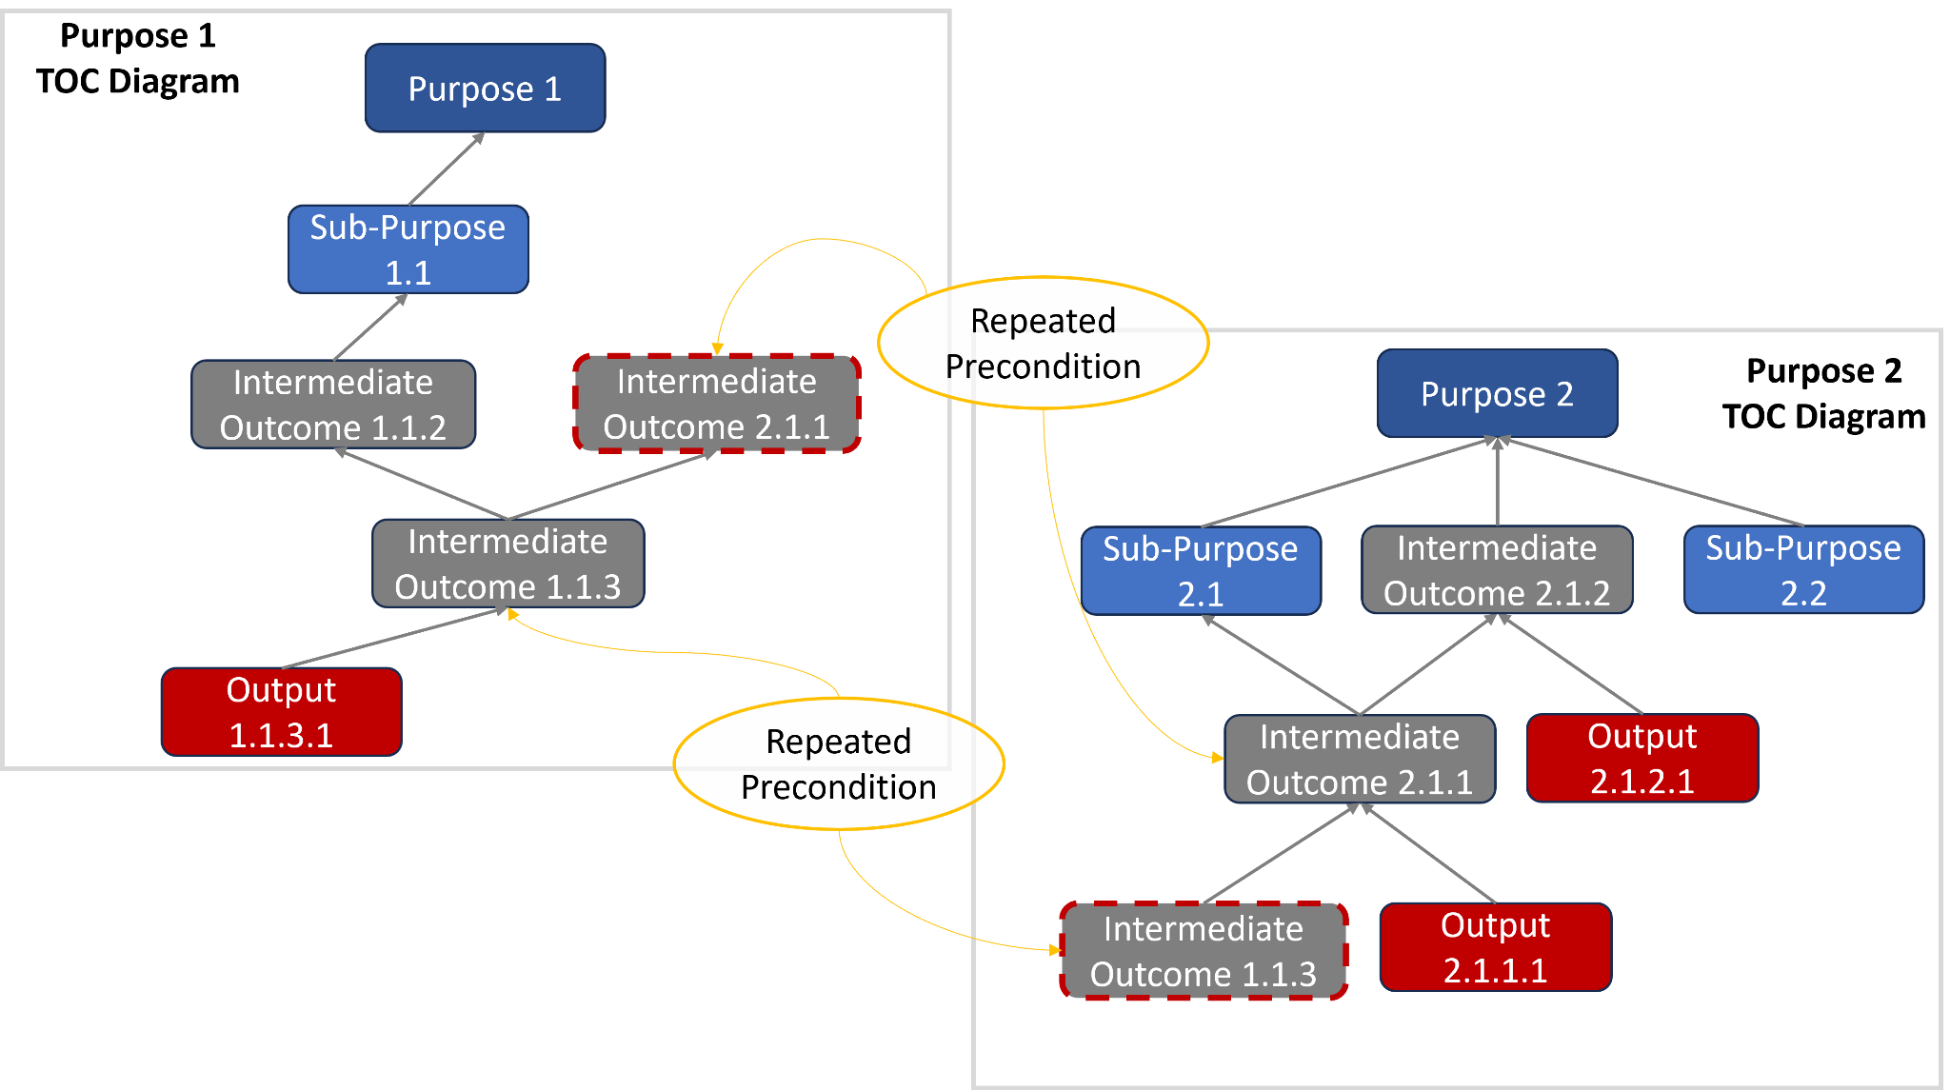

ARTICULATING PATHWAYS IN THE TOC
When designing an activity, it is important to analyze each pathway to determine how critical the pathway is to achieve the purpose. In analyzing the pathway, ask: Will the activity fail to achieve the purpose if the outcome (or sub purpose) is not achieved? For each outcome, are the preconditions necessary and sufficient? There are interventions that contribute to the improvement of the purpose level outcome, but they are not the drivers of the outcome for a particular context. For example, there could be multiple pathways to the purpose “increase access to nutritious food”, including outcomes that support investing in home gardens; investing in skill building; investing in livelihoods development so people can buy nutritious food; investing in poultry rearing; and other pathways.

In order to increase access to nutrition food, the applicant may want to intervene in several pathways depending on the following factors: (1) the potential contribution of each strategy to achieve the outcome of interest; (2) the effort required to implement those strategies; (3) the asset base and livelihoods of the target groups; (4) the potential risks for the recipient and/or community members; and (5) and the operational and cultural context.

Once a pathway (or set of pathways) is determined, analyze each intermediate outcome that would contribute to the sub-purpose. The interventions that are proven to be most critical and effective in achieving the sub-purpose should appear in the TOC (and later be transferred to the LogFrame; see Technical Guidance for Monitoring, Evaluation, and Reporting for Resilience Food Security Activities V2.0 (May 2023) for additional information on LogFrames). In analyzing the sub-purpose pathway, ask the following questions:

- What are the key drivers of the sub purpose?
- How likely will this intervention or set of interventions influence the outcome in this particular context?
- Is this intervention proven to be effective by independent reliable evaluation or research?
- How critical is this intervention to achieving the sub purpose (i.e., what happens if the intervention fails?)?

Through these questions only the most critical and effective drivers or influencers will be identified; interventions that only marginally contribute to an outcome will be dropped. While their inclusion may prove slightly beneficial to achieving results, ultimately these interventions are not cost effective nor essential to activity outcomes. In finalizing a pathway or a set of interventions, an activity design team or implementors must analyze the cost and potential benefit of the pathway or the intervention package.

For example, an activity may plan to promote keyhole gardens to improve household diet quality. To promote high quality keyhole gardens, an activity needs to provide training on keyhole gardens, vegetable production, crop management, and pest management. In addition, often an activity provides seed. Even though it may appear that the per household cost to promote keyhole gardens is fairly low, the cost for the intervention package for the life of the activity may not appear to be low when considering the related interventions and existing circumstances. In addition, the staff or promoter must take the time out from another intervention to provide the training. In spite of the support, keyhole gardens may not be successful because a household needs access to water, and small livestock and poultry often eat the leaves of new growth. Ultimately, even if it is successful, a keyhole garden may contribute only marginally to improving diet quality and it may not be cost effective to influence the ultimate outcome of interest in a particular context, rather it may take resources away from the interventions that could drive the result. In the end, only those outcomes that are critical and effective in achieving the sub purpose, and are supported by evidence, should appear in the LogFrame.

BREADTH, DEPTH, AND LEVEL OF DETAIL IN TOC DIAGRAMS
The “breadth” of the TOC relates to the degree to which it includes external influencing factors. “Depth” refers to how far the TOC follows the preconditions from the Goal. The TOC’s “level of detail” depends on the magnitude of the step between adjacent preconditions and Outcomes in the various pathways of change. The breadth of the TOC submitted with an application should demonstrate comprehensive understanding of the proposed implementation context and be supported by sufficient evidence. The TOC should include the external preconditions that are likely to affect the Outcomes necessary to achieve the activity’s Goal.

BHA requires greater depth for the pathways directly affected by activity interventions than for those produced by other actors. The Outputs from activity interventions must be depicted in the TOC diagram, and the pathways must show how every Output eventually connects to the Goal. For externally-produced outcomes, the TOC diagram should show only the outcome, versus the entire output pathway and identify the actor who is expected to produce the outcome. In the complementary documentation, identify sources of risk to the existence of that necessary precondition, and describe the consequences to higher-level Outcomes if the precondition does not exist.

The abridged TOC submitted at application should chart the Intermediate Outcomes that lead to the Sub-Purpose (from the Goal) and provide enough detail so a reader who is unfamiliar with the activity can understand how changes are expected to unfold. Recipients are required to further develop and revise the TOC during the refinement or contextualization phase (to include the causal pathways from Outputs to Goal), and submit an updated and complete TOC with their comprehensive M&E Plan after the end of the refinement or contextualization phase. During the implementation period, the recipient then submits an updated and complete TOC and M&E Plan annually three months prior to PREP submission. See Technical Guidance for Monitoring, Evaluation, and Reporting for Resilience Food Security Activities V2.0 (May 2023) for additional information on M&E Plan submission timeline.)

TOC COMPLEMENTARY DOCUMENTATION
The TOC complementary documentation should not summarize or reiterate what is obvious from the TOC diagrams. Rather, it should add supplemental information that is not easily communicated graphically or expressed in a few words on a diagram. It should refer to evidence used to develop the TOC and help an external reader understand the degree of certainty that the pathways portrayed in the diagrams will occur. The complementary documentation should, when appropriate:

- Add detail about assumptions: For example, describe trends that indicate growing or declining stability and the sources of risk. It can also highlight the Outcomes that are at greater or lesser risk if conditions change or an assumption fails. In cases of instability or high risk, the narrative or table may be used to describe how the activity will monitor conditions and act to mitigate the risks or effects of the changes.

- Explain rationales: Provide text, web links, or references to scholarly or gray literature that justify connections or causal pathways that are not widely known. For example, this may include studies that show children are more likely to be fed a more nutritious diet if both parents contribute to decisions about feeding as opposed to one parent.

- Add detail on actors outside the activity who are intervening or will intervene to produce critical Outcomes or Outputs that are preconditions in a TOC pathway; the scale of their intervention relative to the activity’s coverage; the likelihood that the preconditions will be achieved by the time they are necessary for the TOC; and the risks if they are not. It may also describe anticipated collaboration with each actor, how that collaboration will better ensure the preconditions, and how Outputs and Outcomes will be monitored.

- If an intervention is expected to influence a population level change, explain how the intervention with a limited number of participants will result in population-level change. Some activities use community-based interventions whereas others target a large proportion of the population in each community to reach a critical mass, develop activities and processes in such a way that they will self-replicate, or use the activity participants as change agents in the community. Also, the complementary documentation developed during the refinement or contextualization period can be used to provide an explanation of the implementation approach if it is not readily apparent in the TOC diagram.

CROSS-CUTTING TECHNICAL AREAS
Activities integrate cross-cutting technical areas of gender, environment, community participation,and/or conflict-sensitivity in different ways. The TOC diagram and complementary documents should clearly show how the activity has integrated these cross-cutting areas.

Some activities implement specific interventions in cross-cutting technical areas to promote attitude changes or practices of a specific group of participants, or to make structural or organizational changes in a community or natural environment. For example, an activity may undertake interventions that transmit key messages related to gender equity to the general community (e.g., through mass media) or at sites of community events (e.g., performing dramas at sites of food distribution and seed fairs). Some work with target communities on kitchen performance tests for better fuel-efficient cooking stoves during nutrition interventions to improve indoor air quality while messaging on more-effective timber harvesting and charcoal production. Others may facilitate discussions about principles of conflict avoidance and resolution among community leaders, married couples, community organizations, or the general community. Pathways depicting these kinds of interventions that directly relate to a cross-cutting Purpose may be depicted in a diagram on a page dedicated to that cross-cutting Purpose, in which case the diagram should show connections to diagrams for other activity Purposes (see Figure 4).

Some activities integrate cross-cutting technical areas into the implementation methods for interventions that contribute more directly to other Purposes and sectors. For example, interventions to promote savings and loans are gender-responsive when their objectives and training consider that men and women might have different objectives for saving or borrowing or face different barriers to saving. In another example, an activity may drill wells for irrigation and foster a municipal governance structure to ensure that these valuable resources are used in a productive and sustainable manner. Many improved agricultural practices benefit the natural environment as well as crop production. In these cases, the cross-cutting integration may be represented in the TOC in the wording of the Outcomes and Outputs in the diagrams for the other Purposes, for example, by using keywords like “men/women,” “climate change sensitive,” “good environmental practices,” “gender-responsive,” “gender-equitable,” “with broad community input,” “inclusive,” and “conflict-sensitive.”

5. REVIEWING THEORIES OF CHANGE

Recipients must review and revise the activity-level TOC during the refinement period and at least annually prior to annual M&E Plan submission. BHA recommends that recipients convene activity stakeholders from all sectors to review the activity’s implementation, progress, and factors that have affected either the implementation or outcomes, and examine validity of the underlying assumptions in the current context. The TOC review should be informed by a variety of available data sources, and include the review of existing sector specific research or analysis reports, assessment findings, formative research, qualitative inquiries, community consultations, monitoring data, recent evaluations, learning events, stakeholder consultations, recipient and program participants’ experiences, and secondary or other sources of information. For annual reviews, monitoring and other contextual data should be collected, analyzed, and organized early in the preparatory process so that the review itself can focus on learning from the data and using that learning to inform programmatic and/or operational change.

Other considerations for undertaking a TOC review include thinking through who should lead the process and who should participate. Recipients may choose how to best facilitate the review, but the process should emphasize the use of data to review the progress or lack of progress along the pathways. (A lack of progress does not always mean that there was a problem with the theory. For example, there could have been an issue with implementation.) The TOC review also provides an opportunity for staff to assess how useful the M&E data are in measuring changes and issues of interest to the activity.

REVIEWING THE TOC THROUGHOUT THE LOA
During the refinement or contextualization period, the TOC refinement should be ongoing and focus on filling evidence gaps and logical inconsistencies, reviewing the sustainability pathways, eliminating pathways that may have marginal contribution to achieve the higher-level outcomes, identifying areas that need further analysis to revise the income pathways, validating assumptions, and refining the design of the activity. (Note that some activities may begin some implementation during the refinement or contextualization period with AOR approval, e.g. to commence implementation of tried-and-true interventions that have a robust evidence base in the operational context.)

The TOC review should take place at least annually (prior to M&E Plan submission) and use monitoring data to review the TOC pathways and progress from outputs to intermediate outcomes, as well as early indications of systemic changes. In addition, the review should also look at the Outputs to promote sustainability and indications of early outcomes.

After the midterm evaluation or process evaluation, the TOC should be revised based on the recommendations and begin to verify lower level results and their contributions to expected outcomes. TOC reviews near the end of the LOA can verify that higher level outcomes will achieve endline targets.

Additional, sector-specific reviews with all or a subset of activity stakeholders may also be useful. To facilitate the review of TOC, the recipient should gather quantitative monitoring indicator data and qualitative information to understand performance indicators, context, and assumptions. Examples of evidence or situational factors that might prompt a special revision to a TOC diagram and/or narrative at any time include:

- An intervention or intermediate outcome that failed to influence a higher-level outcome, even if high quality implementation and all other preconditions in the TOC were met (e.g., household income increased and knowledge of child nutrition improved, but child feeding practices did not improve).
- An intervention output that contributed to an unanticipated outcome or contributed to other outcomes in unexpected ways. For example, new boreholes drilled near a village that were intended to provide water for the community’s livestock attracted a nomadic group that forcibly took control of the wells.

- A set of outputs were delivered and the indicator target was met; however, the logical anticipated outcome from the outputs has not yet been achieved, and the activity does not have a good understanding of the quality of implementation.
- Activity monitoring or a special study that revealed that the quality of, or efficiency in, reaching outcomes depends on additional factors not portrayed in the TOC. For example, some participants may have been quicker to adopt key practices than anticipated or compared to other groups; a gender analysis may have found that previously unrecognized cultural factors are in fact barriers to adoption of key practices; or findings from a qualitative study may indicate that an intervention is not leading to intended change and identify potential implementation changes.
- New research external to the activity that supports previously unknown causal pathways or refutes previously accepted pathways portrayed in the TOC. For example, peer-reviewed literature and/or meta-analyses suggest for the first time that a factor prevalent in the activity area can contribute to diarrheal disease.
- Significant changes in the political or environmental conditions of the local context.

The TOC should be revised and submitted annually as part of the M&E Plan submission three months before PREP submission. Recipients should provide a clear description of how the TOC was changed and what processes were used to revise and update the TOC. In addition to the annual submission prior to the PREP, the recipient may request AOR approval of a revised TOC at any time.

6. RESOURCES

- The Theory of Change Training Curriculum developed by IDEAL and the TOPS Program includes materials to support TOC design and revision. Additional materials include Planning for TOC Development, TOC Process Quality Check Booklet and Facilitators Guide. The TOC Checklist is a useful tool to ensure the completeness and quality of TOC diagrams and complementary documentation. A TOC review facilitator guide is also available on the Food Security and Nutrition Network (www.fsnnetwork.org).
- The Center for Theory of Change promotes best practices for the development and implementation of a TOC. It particularly emphasizes its application in the areas of international development and sustainability.
- The Annie E. Casey Foundation has a Practical Tool for Action, Results and Learning that helps in the development and application of a TOC.
- A blog in the Stanford Social Innovation Review discusses pitfalls to avoid when designing and applying a TOC.
- The Overseas Development Institute offers short planning tools on problem tree analysis.
- The Evaluation Toolbox provides a how-to guide for problem tree/solution tree analysis.
- The Theory of Change Review as an Adaptive Management Tool is a guide on conducting TOC reviews on the USAID Learning Lab.

