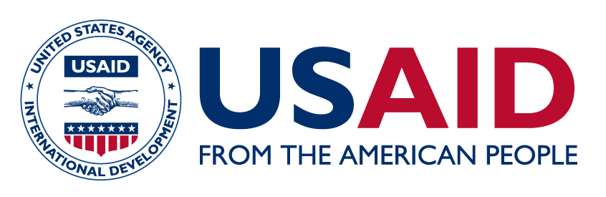

Organizational Gender Equality SWOT Analysis
Instructions: Working with colleagues from your organization, conduct a gender equality Strengths, Weaknesses, Opportunities, and Threats (SWOT). If possible, work collaboratively with your colleagues using this shared google template. The template is also available below. If you are unable to complete your SWOT, you can continue working on this exercise with your colleagues later.

- Strengths: What are the principle strengths that support gender equality? People, policies, processes that are in favor?
- Weaknesses: What are the internal weaknesses or challenges to gender equality? People, policies, processes that are obstacles to gender equality?
- Opportunities: Are there external factors or opportunities that can advance gender equality at the organization?
- Threats: Are there external factors or obstacles to advancing gender equality at the organization?

STRENGTHS

WEAKNESSES

OPPORTUNITIES

THREATS

SWOT
SWOT

