The Gender Equality Roadmap Organizational Phase Assessment
Instructions: Work with colleagues from your organization to determine where your organization is on the gender equality roadmap. Review the phases presented in the graphic below, then fill out the chart on the following page. Participants may choose to work collaboratively on a soft (electronic) copy. It is okay if you don’t have enough time to complete this in full; it is a chance to get started with a facilitator’s support, and you can work with your colleagues to complete the exercise after the session. This exercise will help you develop strategic priorities in your Gender Equality Action Plan.
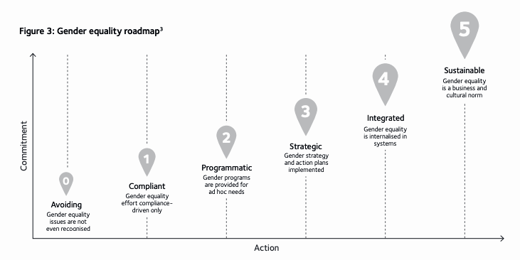

The Gender Equality Roadmap

Phase | Characteristics | Applies to my/our organization (yes/no) | Comment/  Explanation
Avoiding | Structural and cultural barriers to female career progression are unrecognized or denied.
 | Exclusive and/or discriminatory behavior towards women accepted and/or normalized.
 | No measurement or reporting of gender representation or equality issues.
 | No-one accepts (or sees a need to allocate) accountability for gender equality /diversity.
Compliant | Gender equality /diversity are seen as a compliance risk, not a business enabler or imperative.
 | Any gender equality/diversity activity is limited to meeting compliance obligations.
 | Responsibility for compliance with gender legislation or regulation is owned by support functions.
 | Only data required to meet compliance obligations is gathered and is not exploited.
Programmatic | Gender equality/diversity activity occurs only in response to issues that can’t be ignored.
 | Actions and initiatives are ad hoc, reactive and tactical rather than planned, proactive and strategic.
 | Gender initiatives are disconnected and fragmented, which limits synergies, efficiencies and impact.
 | Business priorities take precedence and displace gender equality action if/when necessary.
 | Failure of gender programs initiatives to achieve progress or change undermines long-term support.
Strategic | A specific business case for addressing gender equality is identified and promoted by leaders.
 | A gender strategy is developed which links to and supports business strategy and objectives.
 | Gender strategy is used to guide effort, investment and specific initiatives and is regularly reviewed.
 | Action plans are developed and implemented to realize gender equality strategic objectives.
 | Governance and reporting mechanisms are in place to ensure leadership oversight.
Integrated | Gender equality best practice is integrated into business and people policies and processes.
 | The business case for gender equality is understood and embraced at all organizational levels.
 | Commitment to, and investment in, gender equality progress is unaffected by business challenges.
 | Structural and cultural barriers to female career progression are actively challenged and addressed.
Sustainable | Business leaders hold themselves and their people publicly accountable for gender equality outcomes.
 | Leaders have the necessary capability, confidence and commitment to build gender inclusive culture(s).
 | The organization and its leaders are role models for gender equality/inclusion, and influence others.
 | Ongoing commitment to gender equality is unaffected by changes in leadership composition.
 | Gender equality is simply part of how business is done, and how people work together – always.

